Приложение А
Диаграмма вариантов использования

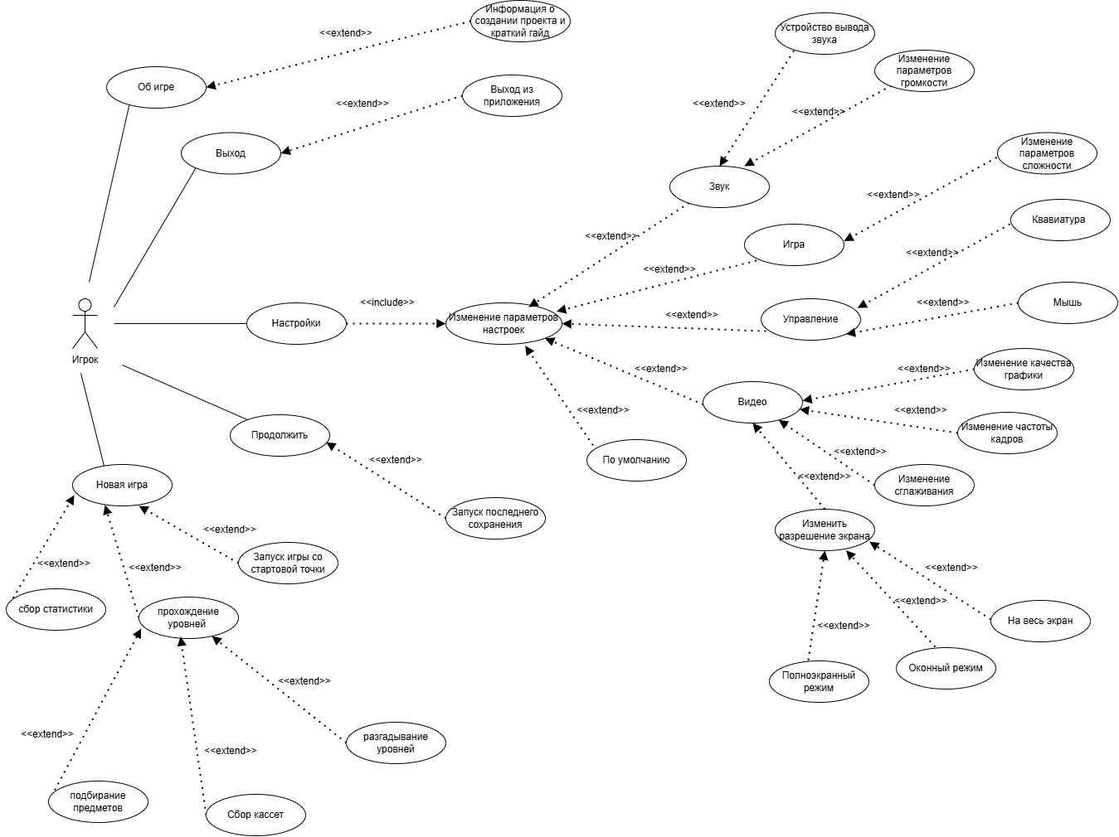

Приложение Б
Диаграмма классов

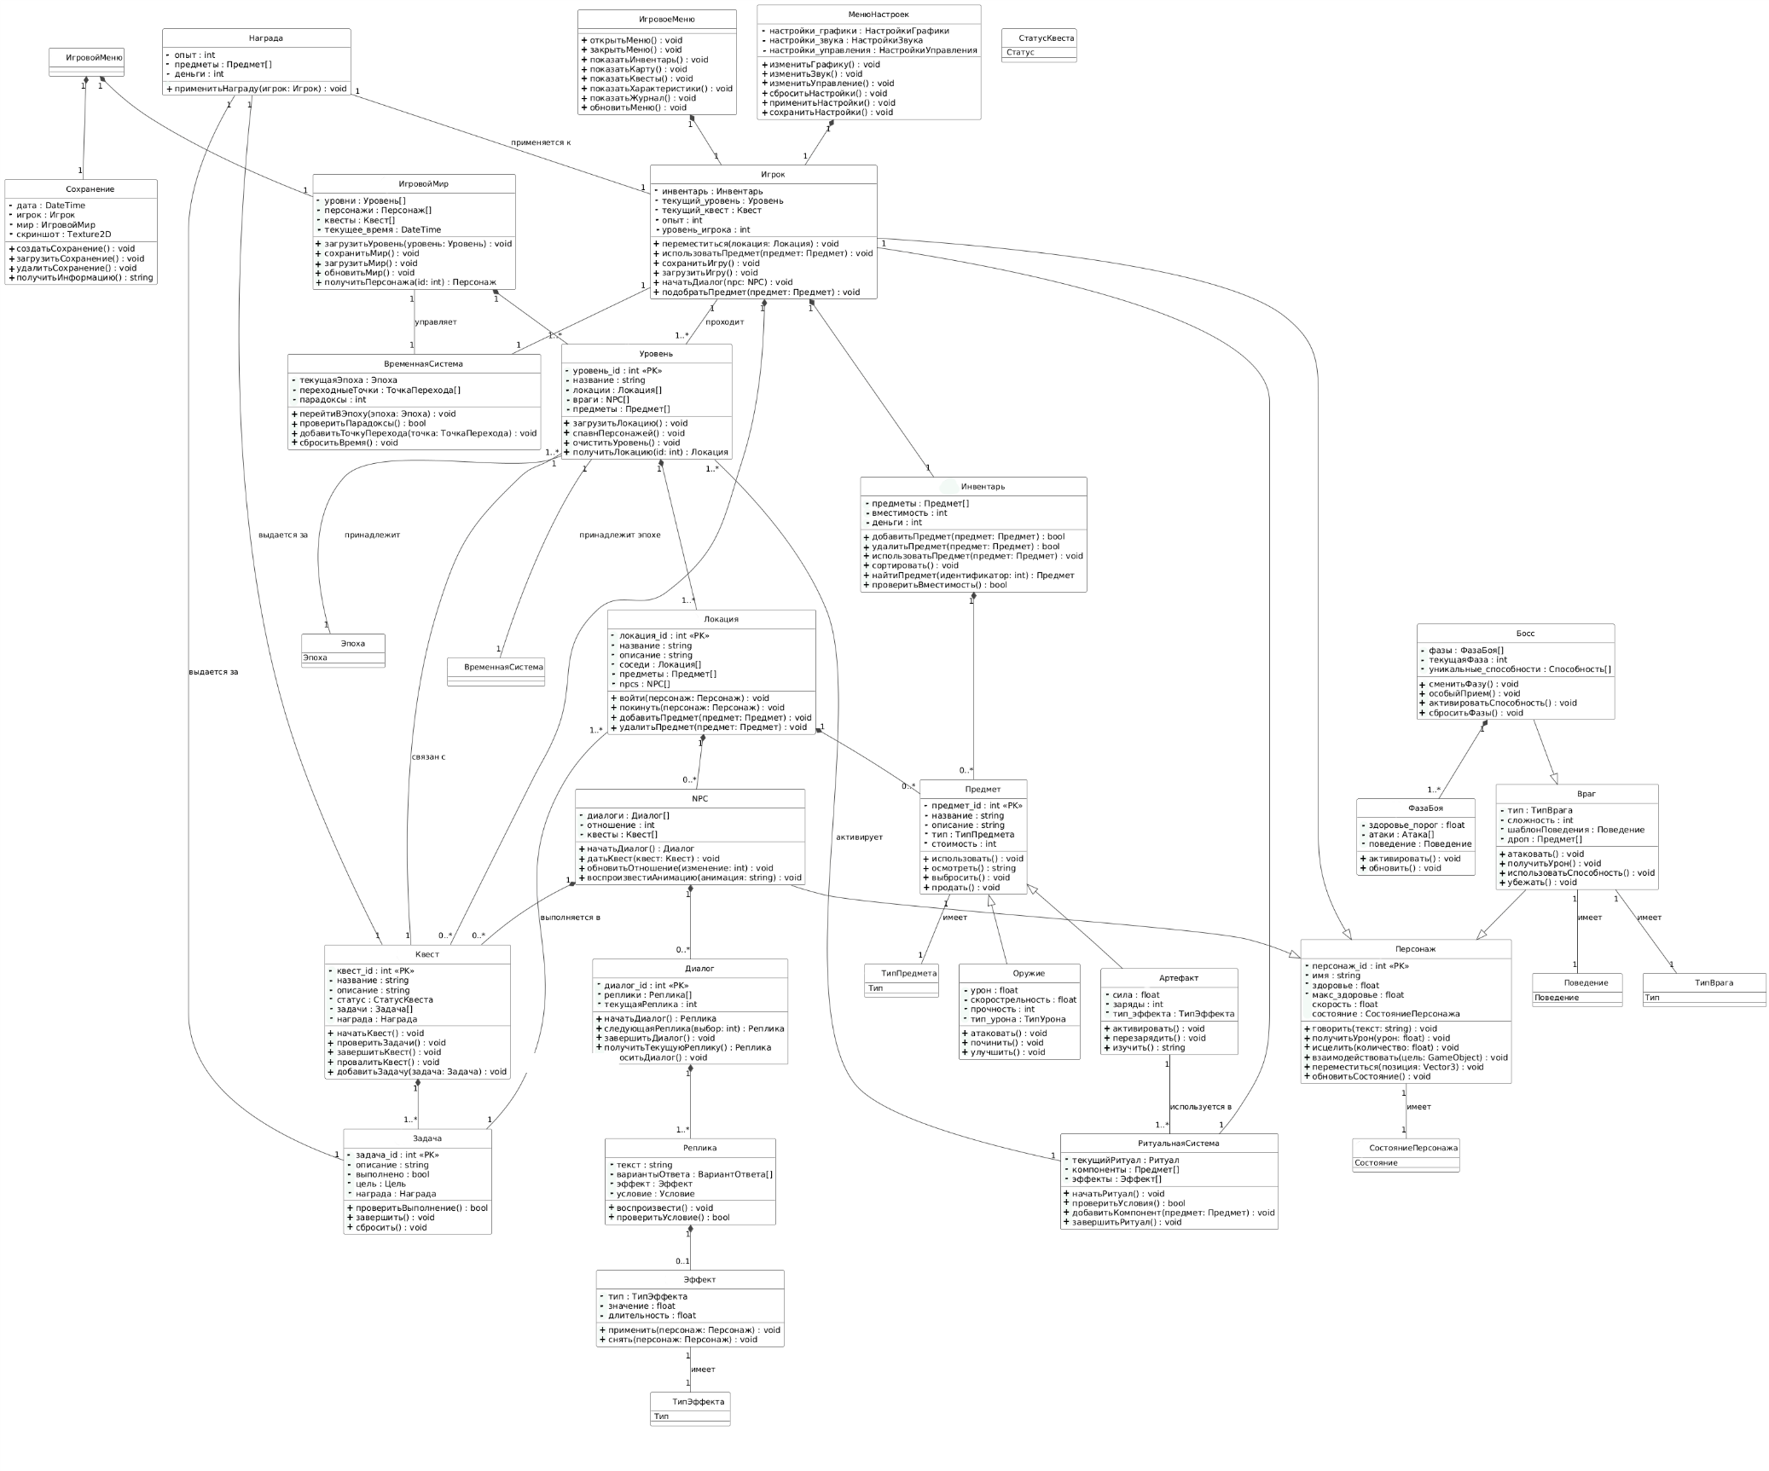

Приложение В
Модели персонажей, карты и меню

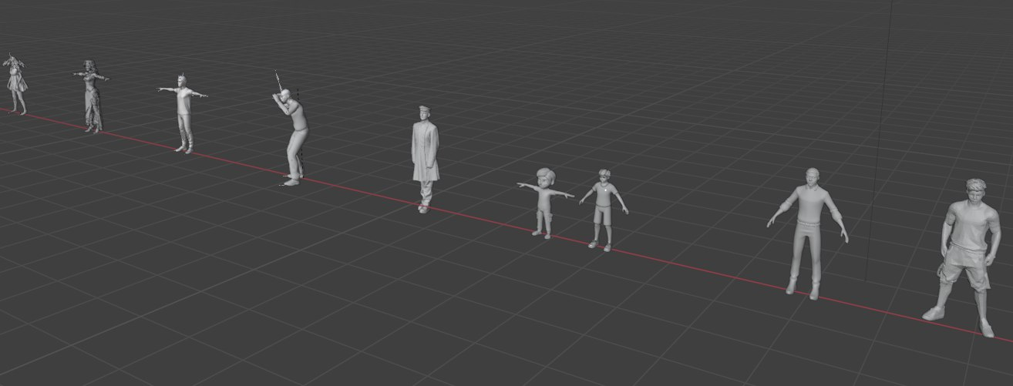
Все модели персонажей(Рисунок 1-11)

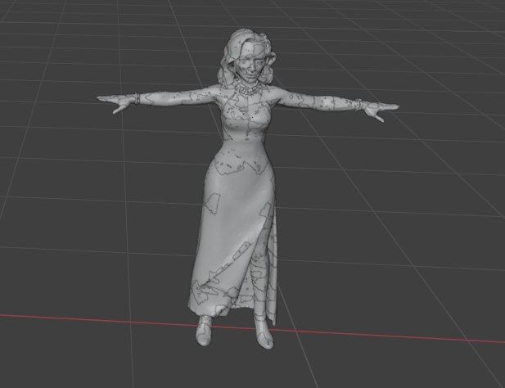
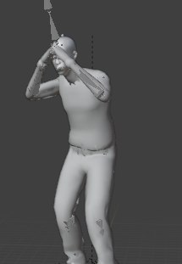
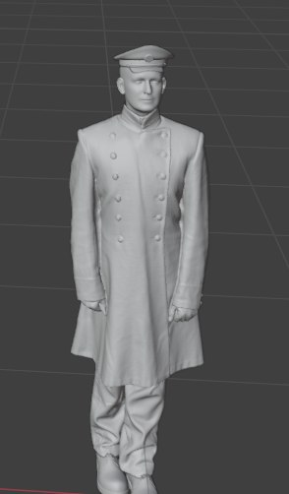

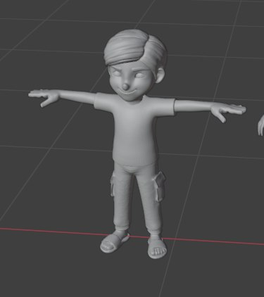
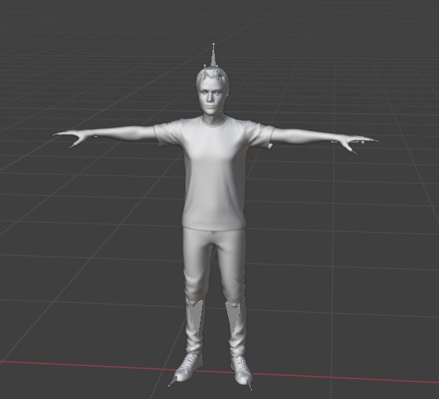
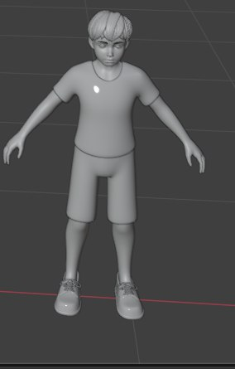

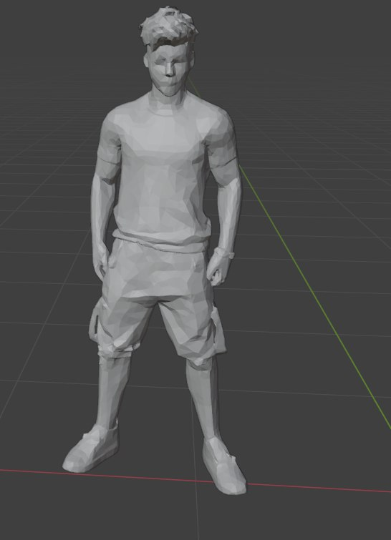
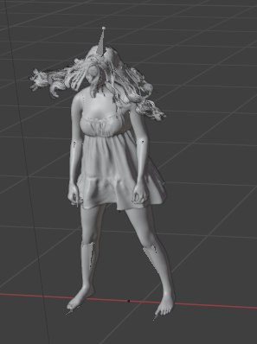
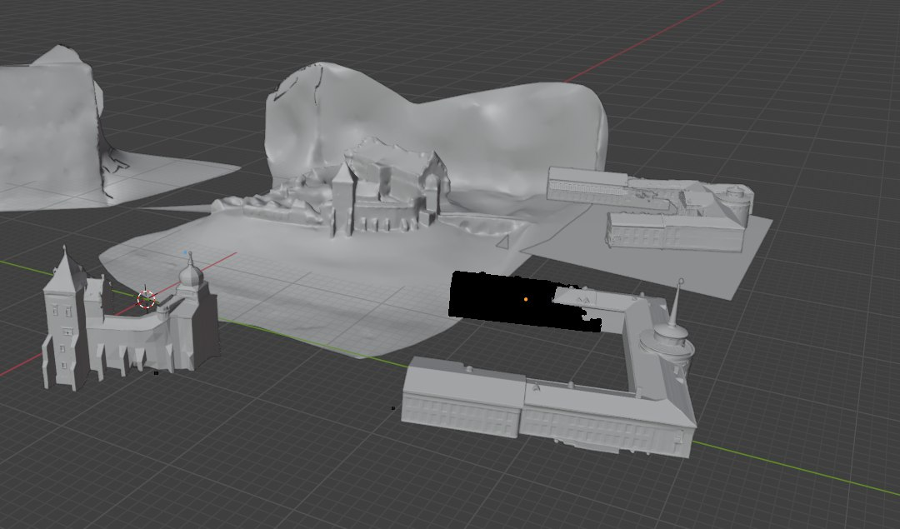
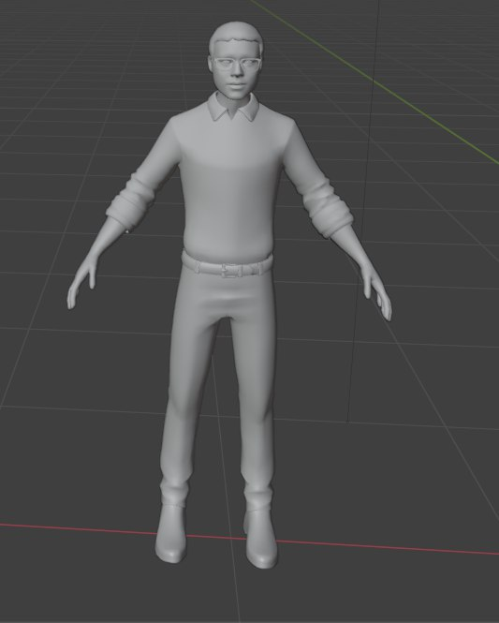

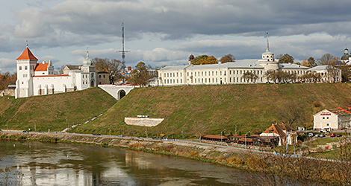

4 уровень – Старый и новый замки.(Рисунок 12)
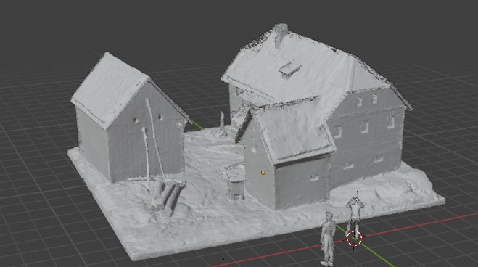
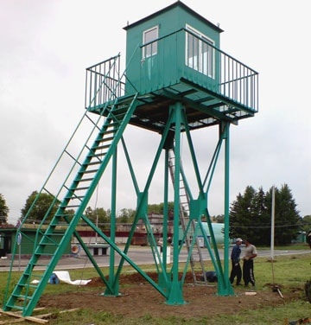
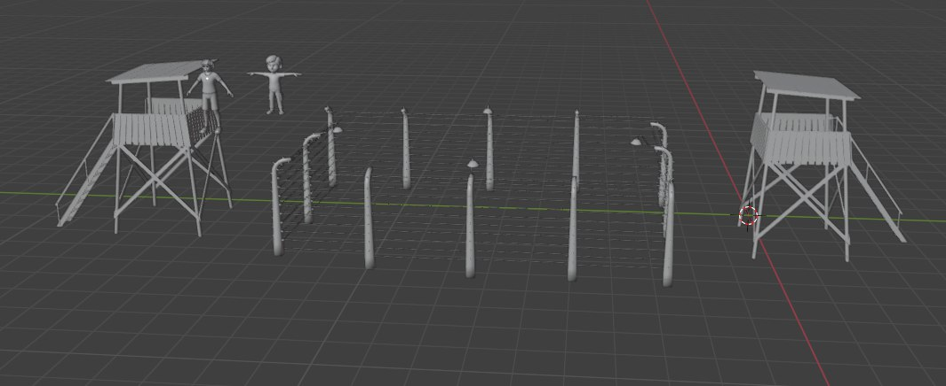
3 уровень - Усадьба.(Рисунок 13)
2 уровень – Лагерь(Рисунок 14)
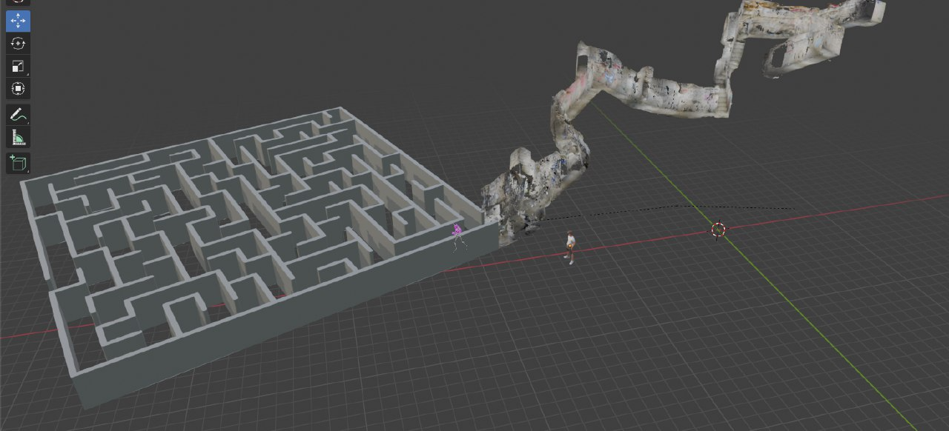
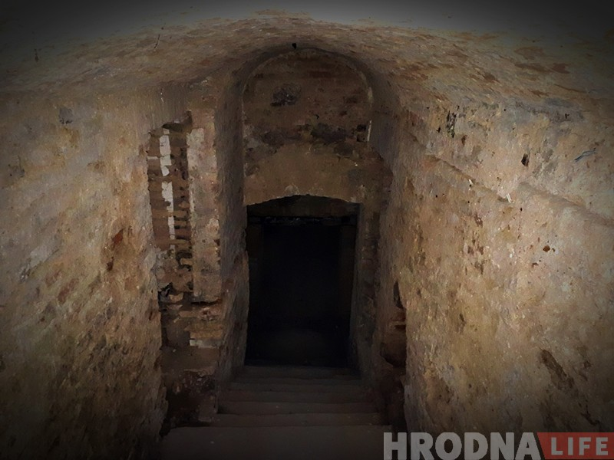
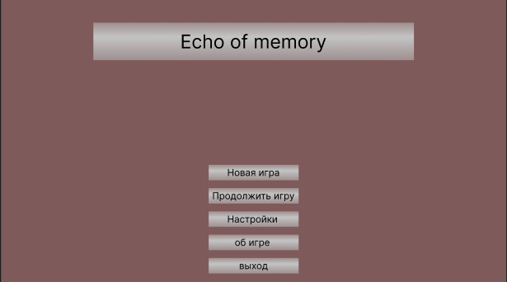
1 уровень – лабиринт(Рисунок 15)
Рисунок 16 – Главное меню
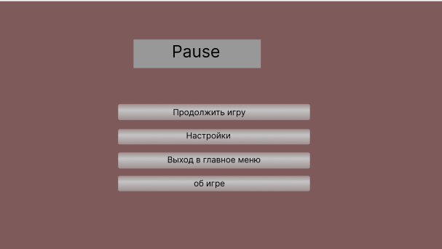
Рисунок 17 – Меню паузы
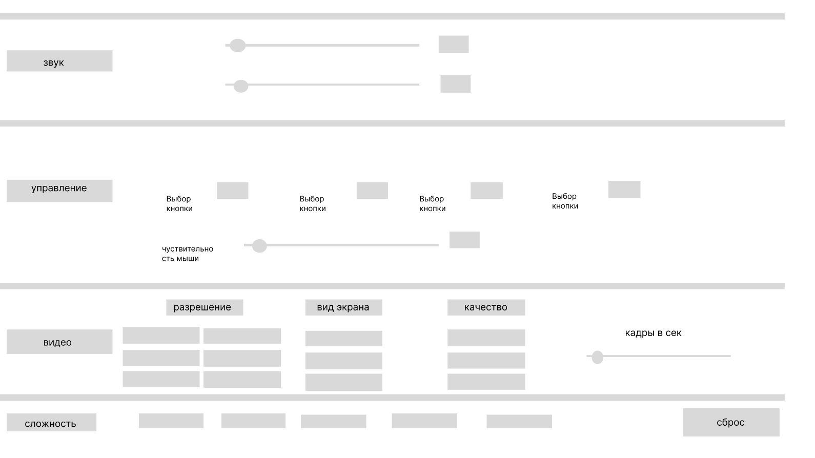
Рисунок 18 – Интерфейс игровой сцены
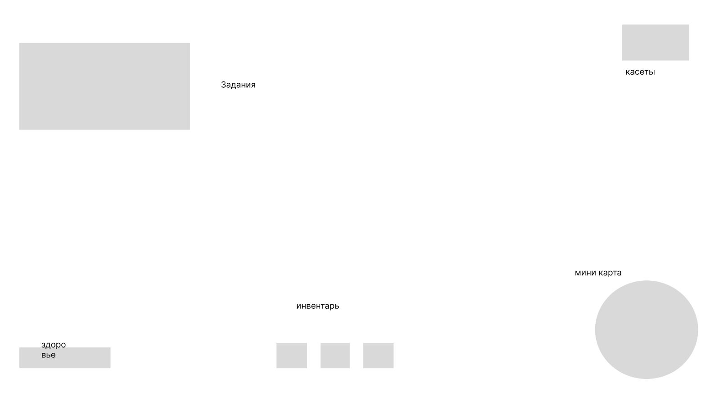
Рисунок 19 – Меню настроек
Ссылка на фигму: Untitled

Приложение Г
Листинг

using UnityEngine;
using System.Collections.Generic;

public class PlayerController : MonoBehaviour
{
[Header("Настройки движения")]
public float walkSpeed = 5f;
public float runSpeed = 8f;
public float jumpForce = 1.5f;
public float gravity = -15f;
public float crouchSpeed = 2.5f;
public float crouchHeight = 1f;
private float originalHeight;
private bool isCrouching = false;
private Vector3 originalCameraPosition;
private Vector3 originalCenter;

[Header("Настройки камеры")]
public float mouseSensitivity = 2f;

[Header("Настройки поднятия предметов")]
public float pickupRange = 5f;
public float throwForce = 10f;
public float rotateSensitivity = 1.5f;
public Vector3 holdOffset = new Vector3(0, -0.1f, 1f);

[Header("Настройки подсветки")]
public Color outlineColor = Color.yellow;
public float outlineWidth = 0.05f;

[Header("Здоровье и стамина")]
public float maxHealth = 100f;
public float maxStamina = 100f;

// Компоненты
private CharacterController controller;
private Camera playerCamera;
private Transform cameraTransform;
private Transform holdPosition;

// Переменные камеры
private float cameraPitch = 0f;
private float cameraYaw = 0f;
private bool isCameraLocked = false;

// Переменные движения
private Vector3 velocity;
private bool isGrounded;
private bool isMoving = false;

// Поднятие предметов
private GameObject heldObject;
private Rigidbody heldObjectRb;
private bool isHolding = false;
private float objectRotationX = 0f;
private float objectRotationY = 0f;

// Подсветка предметов
private GameObject highlightedObject;
private List<Material> originalMaterials = new List<Material>();
private bool isOutlineApplied = false;

// Статистика
private float health;
private float stamina;

// Для отображения UI
private bool showUI = true;
private string interactMessage = "";

void Start()
{
Debug.Log("=== ИНИЦИАЛИЗАЦИЯ ИГРОКА ===");

// CharacterController
controller = GetComponent<CharacterController>();
if (controller == null)
{
controller = gameObject.AddComponent<CharacterController>();
controller.height = 2f;
controller.radius = 0.3f;
controller.center = new Vector3(0, 1f, 0);
}

originalHeight = controller.height;
originalCenter = controller.center;

// Устанавливаем позицию персонажа как в координатах
transform.position = new Vector3(0.1711886f, 0.46f, 0.00840497f);
Debug.Log($"Позиция персонажа установлена: {transform.position}");

// Камера
playerCamera = GetComponentInChildren<Camera>();
if (playerCamera == null)
{
playerCamera = Camera.main;
if (playerCamera == null)
{
GameObject camObj = new GameObject("PlayerCamera");
camObj.transform.SetParent(transform);
playerCamera = camObj.AddComponent<Camera>();
camObj.AddComponent<AudioListener>();
}
else
{
playerCamera.transform.SetParent(transform);
}
}

// Позиционируем камеру
playerCamera.transform.localPosition = new Vector3(0, 0.5f, 0);
originalCameraPosition = playerCamera.transform.localPosition;
playerCamera.transform.localRotation = Quaternion.identity;
cameraTransform = playerCamera.transform;

// Создаём позицию для удержания предметов
GameObject holdPos = new GameObject("HoldPosition");
holdPos.transform.SetParent(cameraTransform);
holdPos.transform.localPosition = holdOffset;
holdPos.transform.localRotation = Quaternion.identity;
holdPosition = holdPos.transform;

// Инициализируем значения
health = maxHealth;
stamina = maxStamina;

// Настраиваем курсор
Cursor.lockState = CursorLockMode.Locked;
Cursor.visible = false;

Debug.Log("Готово! Управление:");
Debug.Log("WASD - движение");
Debug.Log("Shift - БЕЖАТЬ (тратит стамину)");
Debug.Log("Ctrl - присесть");
Debug.Log("Space - прыжок (маленький)");
Debug.Log("E - взять/бросить предмет");
Debug.Log("ПКМ - вращать предмет");
Debug.Log("H - тестово нанести 10 урона");
Debug.Log("F1 - скрыть/показать здоровье и стамину");
}

void Update()
{
HandleMovement();
HandleCrouch();
HandleStamina();
HandlePickupSystem();
CheckFalling();

if (!isCameraLocked)
{
HandleCamera();
}
else
{
if (Input.GetMouseButton(1))
{
HandleObjectRotation();
}
}

if (Input.GetKeyDown(KeyCode.H))
{
TakeDamage(10f);
Debug.Log("Нанесён тестовый урон 10 HP! Здоровье: " + health);
}

if (Input.GetKeyDown(KeyCode.F1))
{
showUI = !showUI;
Debug.Log("Здоровье и стамина " + (showUI ? "показаны" : "скрыты"));
}
}

void OnGUI()
{
if (!showUI) return;

GUIStyle healthStyle = new GUIStyle(GUI.skin.label);
healthStyle.fontSize = 16;
healthStyle.normal.textColor = Color.red;
healthStyle.fontStyle = FontStyle.Bold;

GUIStyle staminaStyle = new GUIStyle(GUI.skin.label);
staminaStyle.fontSize = 16;
staminaStyle.normal.textColor = Color.green;
staminaStyle.fontStyle = FontStyle.Bold;

GUIStyle interactStyle = new GUIStyle(GUI.skin.label);
interactStyle.fontSize = 14;
interactStyle.normal.textColor = Color.yellow;
interactStyle.alignment = TextAnchor.MiddleCenter;

GUIStyle crouchStyle = new GUIStyle(GUI.skin.label);
crouchStyle.fontSize = 12;
crouchStyle.normal.textColor = Color.cyan;
crouchStyle.fontStyle = FontStyle.Bold;

GUI.Label(new Rect(10, 10, 300, 25), "❤ Здоровье: " + Mathf.RoundToInt(health) + "/" + maxHealth, healthStyle);

Color staminaColor = stamina < 30f ? Color.red : (stamina < 60f ? Color.yellow : Color.green);
staminaStyle.normal.textColor = staminaColor;
GUI.Label(new Rect(10, 35, 300, 25), "⚡ Стамина: " + Mathf.RoundToInt(stamina) + "/" + maxStamina, staminaStyle);

if (!string.IsNullOrEmpty(interactMessage))
{
GUI.Label(new Rect(Screen.width / 2 - 200, Screen.height - 80, 400, 30), interactMessage, interactStyle);
}

if (isCrouching)
{
GUI.Label(new Rect(10, 60, 400, 20), "Приседание (отпустите Ctrl чтобы встать)", crouchStyle);
}
}

void HandleCamera()
{
float mouseX = Input.GetAxis("Mouse X") * mouseSensitivity;
float mouseY = Input.GetAxis("Mouse Y") * mouseSensitivity;

cameraYaw += mouseX;
transform.rotation = Quaternion.Euler(0, cameraYaw, 0);

cameraPitch -= mouseY;
cameraPitch = Mathf.Clamp(cameraPitch, -90f, 90f);

cameraTransform.localEulerAngles = new Vector3(cameraPitch, 0f, 0f);
}

void HandleMovement()
{
isGrounded = controller.isGrounded;

if (isGrounded && velocity.y < 0)
{
velocity.y = -2f;
}

// Прыжок
if (Input.GetKeyDown(KeyCode.Space) && isGrounded && stamina > 5f && !isCrouching)
{
velocity.y = Mathf.Sqrt(jumpForce * -2f * gravity);
stamina -= 5f;
}

// Гравитация
velocity.y += gravity * Time.deltaTime;

// Проверяем движение
Vector3 move = Vector3.zero;
isMoving = false;

if (Input.GetKey(KeyCode.W)) { move += transform.forward; isMoving = true; }
if (Input.GetKey(KeyCode.S)) { move -= transform.forward; isMoving = true; }
if (Input.GetKey(KeyCode.A)) { move -= transform.right; isMoving = true; }
if (Input.GetKey(KeyCode.D)) { move += transform.right; isMoving = true; }

if (move.magnitude > 0.1f)
{
move.Normalize();

float speed;
if (isCrouching)
{
speed = crouchSpeed;
}
else
{
// МОЖНО БЕЖАТЬ ТОЛЬКО ЕСЛИ ЕСТЬ СТАМИНА
bool canRun = Input.GetKey(KeyCode.LeftShift) && stamina > 0;
speed = canRun ? runSpeed : walkSpeed;

// Если пытаемся бежать без стамины - пишем в лог
if (Input.GetKey(KeyCode.LeftShift) && stamina <= 0)
{
Debug.Log("Не могу бежать! Стамина на нуле");
}
}

controller.Move(move * speed * Time.deltaTime);
}
else
{
isMoving = false;
}

controller.Move(velocity * Time.deltaTime);
}

void HandleCrouch()
{
bool shouldCrouch = Input.GetKey(KeyCode.LeftControl);

if (shouldCrouch && !isCrouching)
{
isCrouching = true;

Vector3 currentPosition = transform.position;

controller.height = crouchHeight;
controller.center = new Vector3(0, crouchHeight / 2f, 0);

controller.enabled = false;
transform.position = currentPosition;
controller.enabled = true;

cameraTransform.localPosition = Vector3.Lerp(
cameraTransform.localPosition,
new Vector3(0, 0.2f, 0),
Time.deltaTime * 10f
);
}
else if (!shouldCrouch && isCrouching)
{
if (!CheckCeiling())
{
isCrouching = false;

Vector3 currentPosition = transform.position;

controller.height = originalHeight;
controller.center = originalCenter;

controller.enabled = false;
transform.position = currentPosition;
controller.enabled = true;

cameraTransform.localPosition = Vector3.Lerp(
cameraTransform.localPosition,
originalCameraPosition,
Time.deltaTime * 10f
);
}
}

if (isCrouching)
{
cameraTransform.localPosition = Vector3.Lerp(
cameraTransform.localPosition,
new Vector3(0, 0.2f, 0),
Time.deltaTime * 10f
);
}
else if (!isCrouching && !CheckCeiling())
{
cameraTransform.localPosition = Vector3.Lerp(
cameraTransform.localPosition,
originalCameraPosition,
Time.deltaTime * 10f
);
}
}

bool CheckCeiling()
{
RaycastHit hit;
float checkDistance = 0.5f;
Vector3 rayStart = transform.position + Vector3.up * (controller.height / 2f);

bool hasCeiling = Physics.Raycast(rayStart, Vector3.up, out hit, checkDistance);
Debug.DrawRay(rayStart, Vector3.up * checkDistance, hasCeiling ? Color.red : Color.green);

return hasCeiling;
}

void HandleStamina()
{
// МЕДЛЕННОЕ восстановление стамины
if (!Input.GetKey(KeyCode.LeftShift) && stamina < maxStamina)
{
float recoverySpeed = 4f; // Медленно восстанавливаем
stamina += recoverySpeed * Time.deltaTime;
stamina = Mathf.Min(stamina, maxStamina);
}

// МЕДЛЕННАЯ трата стамины при беге
if (Input.GetKey(KeyCode.LeftShift) && isMoving && stamina > 0)
{
float drainSpeed = 15f; //тратим при беге
stamina -= drainSpeed * Time.deltaTime;
stamina = Mathf.Max(stamina, 0);
}
}

void HandlePickupSystem()
{
if (!isHolding)
{
FindAndHighlightPickupableObject();

if (Input.GetKeyDown(KeyCode.E))
{
TryPickup();
}
}
else
{
if (heldObject != null)
{
heldObject.transform.position = holdPosition.position;

if (Input.GetMouseButtonDown(1))
{
StartObjectRotation();
}

if (Input.GetMouseButtonUp(1))
{
StopObjectRotation();
}

if (Input.GetKeyDown(KeyCode.E))
{
ThrowObject();
}
}
}
}

void FindAndHighlightPickupableObject()
{
Ray ray = new Ray(cameraTransform.position, cameraTransform.forward);
RaycastHit hit;

if (Physics.Raycast(ray, out hit, pickupRange))
{
GameObject obj = hit.collider.gameObject;
Rigidbody rb = obj.GetComponent<Rigidbody>();

if (rb != null && !rb.isKinematic)
{
if (obj != highlightedObject)
{
ClearHighlight();
highlightedObject = obj;
ApplyOutline(obj);
}

interactMessage = "E - Взять " + obj.name + " (расстояние: " + hit.distance.ToString("F1") + "м)";
Debug.DrawRay(ray.origin, ray.direction * hit.distance, Color.green);
return;
}
}

ClearHighlight();
interactMessage = "";
Debug.DrawRay(ray.origin, ray.direction * pickupRange, Color.red);
}

void ApplyOutline(GameObject obj)
{
Renderer[] renderers = obj.GetComponentsInChildren<Renderer>();
originalMaterials.Clear();

foreach (Renderer renderer in renderers)
{
List<Material> rendererMaterials = new List<Material>();
foreach (Material mat in renderer.materials)
{
rendererMaterials.Add(mat);
}
originalMaterials.AddRange(rendererMaterials);

Material[] outlineMaterials = new Material[renderer.materials.Length];
for (int i = 0; i < renderer.materials.Length; i++)
{
Material outlineMat = new Material(Shader.Find("Standard"));
outlineMat.CopyPropertiesFromMaterial(renderer.materials[i]);
outlineMat.EnableKeyword("_EMISSION");
outlineMat.SetColor("_EmissionColor", outlineColor);
outlineMat.SetFloat("_Mode", 3);
outlineMat.SetInt("_SrcBlend", (int)UnityEngine.Rendering.BlendMode.SrcAlpha);
outlineMat.SetInt("_DstBlend", (int)UnityEngine.Rendering.BlendMode.OneMinusSrcAlpha);
outlineMat.SetInt("_ZWrite", 0);
outlineMat.DisableKeyword("_ALPHATEST_ON");
outlineMat.EnableKeyword("_ALPHABLEND_ON");
outlineMat.DisableKeyword("_ALPHAPREMULTIPLY_ON");
outlineMat.renderQueue = 3000;
outlineMaterials[i] = outlineMat;
}

renderer.materials = outlineMaterials;
}

isOutlineApplied = true;
}

void ClearHighlight()
{
if (highlightedObject != null && isOutlineApplied)
{
Renderer[] renderers = highlightedObject.GetComponentsInChildren<Renderer>();

int materialIndex = 0;
foreach (Renderer renderer in renderers)
{
Material[] originalRendererMaterials = new Material[renderer.materials.Length];
for (int i = 0; i < renderer.materials.Length; i++)
{
if (materialIndex < originalMaterials.Count)
{
originalRendererMaterials[i] = originalMaterials[materialIndex];
materialIndex++;
}
}
renderer.materials = originalRendererMaterials;
}

originalMaterials.Clear();
highlightedObject = null;
isOutlineApplied = false;
}
}

void StartObjectRotation()
{
if (isHolding && heldObject != null)
{
isCameraLocked = true;
Cursor.lockState = CursorLockMode.None;
Cursor.visible = true;

objectRotationX = 0f;
objectRotationY = 0f;
interactMessage = "Двигайте мышью для вращения предмета | E - Бросить";
}
}

void StopObjectRotation()
{
if (isCameraLocked)
{
isCameraLocked = false;
Cursor.lockState = CursorLockMode.Locked;
Cursor.visible = false;

if (isHolding)
{
interactMessage = "E - Бросить | ПКМ - Вращать предмет";
}
}
}

void HandleObjectRotation()
{
if (!isHolding || heldObject == null) return;

float mouseX = Input.GetAxis("Mouse X") * rotateSensitivity;
float mouseY = Input.GetAxis("Mouse Y") * rotateSensitivity;

objectRotationX += mouseX;
objectRotationY += mouseY;

objectRotationY = Mathf.Clamp(objectRotationY, -90f, 90f);

Quaternion targetRotation = Quaternion.Euler(objectRotationY, -objectRotationX, 0f);
heldObject.transform.rotation = Quaternion.Lerp(heldObject.transform.rotation, targetRotation, Time.deltaTime * 5f);
}

void TryPickup()
{
Ray ray = new Ray(cameraTransform.position, cameraTransform.forward);
RaycastHit hit;

if (Physics.Raycast(ray, out hit, pickupRange))
{
GameObject obj = hit.collider.gameObject;
Rigidbody rb = obj.GetComponent<Rigidbody>();

if (rb == null || rb.isKinematic)
{
Debug.Log("Нельзя поднять этот предмет");
return;
}

ClearHighlight();

heldObject = obj;
heldObjectRb = rb;
isHolding = true;

heldObjectRb.isKinematic = true;
heldObjectRb.useGravity = false;
heldObjectRb.linearVelocity = Vector3.zero;
heldObjectRb.angularVelocity = Vector3.zero;

Collider col = heldObject.GetComponent<Collider>();
if (col != null) col.enabled = false;

heldObject.layer = 2;

heldObject.transform.SetParent(holdPosition);
heldObject.transform.localPosition = Vector3.zero;
heldObject.transform.localRotation = Quaternion.identity;

objectRotationX = 0f;
objectRotationY = 0f;

Debug.Log("Предмет поднят с расстояния: " + hit.distance.ToString("F1") + " метров");

interactMessage = "E - Бросить | ПКМ - Вращать предмет";
}
else
{
Debug.Log("Предмет слишком далеко! Максимальное расстояние: " + pickupRange + "м");
}
}

void ThrowObject()
{
if (heldObject == null) return;

if (isCameraLocked)
{
StopObjectRotation();
}

Collider col = heldObject.GetComponent<Collider>();
if (col != null) col.enabled = true;

heldObject.layer = 0;

heldObjectRb.isKinematic = false;
heldObjectRb.useGravity = true;

heldObject.transform.SetParent(null);

Vector3 throwDirection = cameraTransform.forward;
heldObjectRb.AddForce(throwDirection * throwForce, ForceMode.Impulse);

heldObjectRb.angularVelocity = new Vector3(
Mathf.Deg2Rad * objectRotationY * 0.2f,
Mathf.Deg2Rad * -objectRotationX * 0.2f,
0
);

heldObject = null;
heldObjectRb = null;
isHolding = false;
interactMessage = "";
}

void CheckFalling()
{
if (transform.position.y < -20f)
{
controller.enabled = false;
transform.position = new Vector3(0.1711886f, 0.46f, 0.00840497f);
velocity = Vector3.zero;
controller.enabled = true;
TakeDamage(20f);
}
}

public void TakeDamage(float damage)
{
health -= damage;
health = Mathf.Max(health, 0f);

if (health <= 0)
{
Respawn();
}
}

void Respawn()
{
controller.enabled = false;
transform.position = new Vector3(0.1711886f, 0.46f, 0.00840497f);
velocity = Vector3.zero;
controller.enabled = true;
health = maxHealth;
stamina = maxStamina;
Debug.Log("Игрок возрождён! Здоровье и стамина восстановлены.");

if (isCrouching)
{
isCrouching = false;
controller.height = originalHeight;
controller.center = originalCenter;
cameraTransform.localPosition = originalCameraPosition;
}
}

void OnDrawGizmosSelected()
{
if (cameraTransform != null)
{
Gizmos.color = Color.blue;
Gizmos.DrawRay(cameraTransform.position, cameraTransform.forward * pickupRange);

Gizmos.color = new Color(0, 0, 1, 0.1f);
Gizmos.DrawWireSphere(cameraTransform.position + cameraTransform.forward * (pickupRange / 2f), pickupRange / 2f);

if (holdPosition != null)
{
Gizmos.color = Color.green;
Gizmos.DrawWireSphere(holdPosition.position, 0.1f);
}
}
}
}

